|  |
| --- |
| Macintosh HD:Users:owner:Downloads:logo.jpgJARGON CORP. |
| External Documentation |
| **[Sky Defender]** |
| Version #0.6  All work Copyright © 2012 by JARGON CORP.  All rights reserved. |
| **Jesse Higgins** |
|  |

|  |
| --- |
| July 9th 2013 |

**Table of Contents**

1. Version History
2. Game Overview
3. Controls
4. Interface Sketch
5. Screen Description
6. Characters/Vehicles
7. Enemies
8. Scoring
9. Sound Index
10. Art/Multimedia Index

**Version History**

**Version 0.1:**

This initial version of Sky Defender was simply creating the parallax background for the game to take place on.

**Version 0.2:**

The player sprite has been added to the screen in this implementation and this player is able to shoot missiles at its enemy.

**Version 0.3:**

The first enemy sprite was added in Version 0.3 for the player sprite to take on and this enemy sprite will reset itself on collision.

**Version 0.4**:

In version 0.4, multiple enemy sprites were added to the game and explosions were added for the effect of hitting them.

**Version 0.5**:

Version 0.5 was simply the next step, which involved implementing a scoring system for the user and also an instruction screen prompting the user how to play!

**Version 0.6**:

Version 0.6 was the final version of Sky Defender in which there was sound implementation and a game over screen that would display the users final score and allow the user to play again by clicking their mouse. This will then bring the user back to the instruction screen.

GitHub Link: <https://github.com/JargonKnight/Intro-To-Graphics.git>

1. **Game Overview**

Sky Defender is a game where you play as a Fighter Plane in the sky flying over the beautiful green hills that the world has to offer. The Sky is being invaded by enemy fighter jets and it is your job to take them all out and fight for as long as you can by firing your missiles at your enemies. You gain a score for all the enemies you take out and with the amazing sound effects, you feel like a real fighter plane pilot!

1. **Controls**

Sky Defender is operated by two simple controls: The movement of your own mouse to control the movement of your fighter plane and the clicking of your mouse for firing your missiles.

1. **Screen Sketch**

Missiles

Player Airplane Sprite

Enemy Sprites

Background

1. **Screen Description**

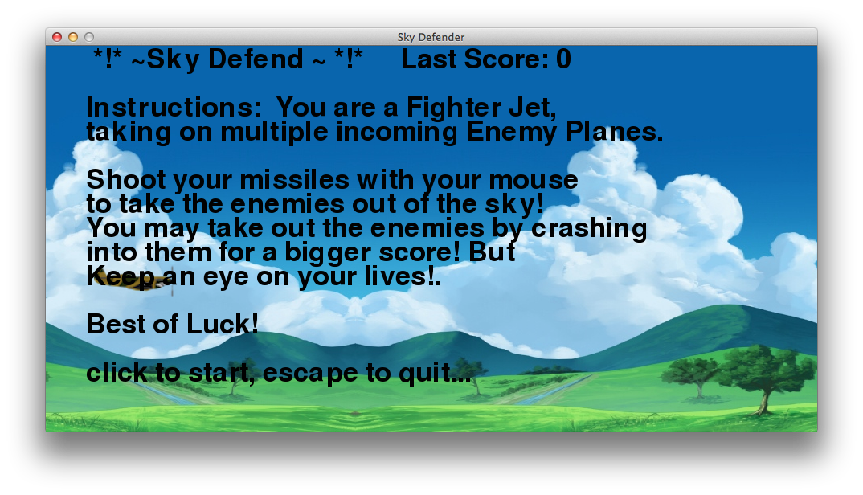

Instruction Screen prompts the user with instructions on how to play the game

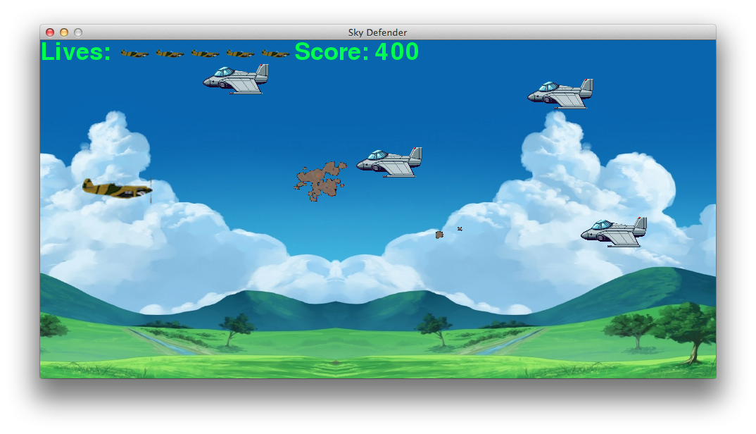

Main game screen shows the players firing missiles and having the enemies explode

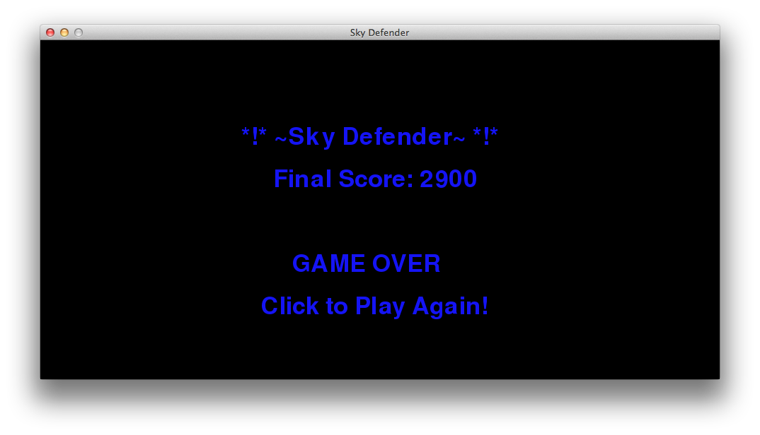

Game Over screen displays the player’s final score and prompts them to play again by clicking their mouse

1. **Characters/Vehicles**

You play as one character in Sky Defender and that is your own Fighter Plane! You only have so much room for moving your plane around so think quickly and be swift!

1. **Enemies**

You have to take on multiple fighter jet enemies during your endeavour to get the highest score you can! Some of your enemies are faster than others so you must be quick and precise with every shot! The enemy fighter jets, on spawn, have randomized speeds and randomized (x,y) coordinates for different locations on the screen.

1. **Scoring**

Each fighter jet you take out with a missile will give you a 200 score. You are allowed to take out your enemies by crashing your plane into them for a bigger 500 score! However, you must keep a keen eye on your lives!

1. **Sound Index**

missileExplode.ogg – used when the missile collides with enemy  
missileFire.ogg – used when a missile is fired from your fighter plane  
planeExplode.ogg – used when your fighter plane collides with an enemy jet  
planeSound.ogg – the ongoing noise of your fighter plane flying through the sky

1. **Art/Multimedia Index**

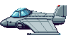 -Enemy fighter jet

 - missile  
 

Parallax Background

 - lives counter image for plane lives

 - Fighter plane used by player